DV SAN certificate
# Source: AI Source: Provided by: [Data Path: Persons Table -> ID Column: 1, Name_En Column: Motasem Essam] -> From: [ChatGPT] on [1/18/2026]
A DV SAN certificate is a Domain Validation (DV) SSL/TLS certificate that can secure multiple different domains (and optionally subdomains) in a single certificate using Subject Alternative Names (SANs).

🔐 What DV SAN Means
# Source: AI Source: Provided by: [Data Path: Persons Table -> ID Column: 1, Name_En Column: Motasem Essam] -> From: [ChatGPT] on [1/18/2026]
- DV (Domain Validation) → verifies only domain ownership
- SAN (Subject Alternative Name) → allows multiple domains to be listed in one certificate
- Fast, automated, and cost-effective
Example SAN List
example.com
www.example.com
api.example.org
blog.example.net
All of these domains are secured with one DV SAN certificate.

🛠️ How It Works
# Source: AI Source: Provided by: [Data Path: Persons Table -> ID Column: 1, Name_En Column: Motasem Essam] -> From: [ChatGPT] on [1/18/2026]
- The CA verifies domain ownership for each listed domain
  - Usually via DNS TXT records or email verification
- CA issues a certificate containing all the SAN entries
- Browsers check the requested domain against the SAN list
- HTTPS connection is established if matched

📍 Where DV SAN Certificates Are Used
# Source: AI Source: Provided by: [Data Path: Persons Table -> ID Column: 1, Name_En Column: Motasem Essam] -> From: [ChatGPT] on [1/18/2026]
- Companies managing multiple small websites
- SaaS platforms with multiple domains
- Internal tools or dev environments
- APIs across multiple domains

✅ Advantages
# Source: AI Source: Provided by: [Data Path: Persons Table -> ID Column: 1, Name_En Column: Motasem Essam] -> From: [ChatGPT] on [1/18/2026]
- One certificate for multiple domains
- Fast issuance (minutes to hours)
- Low cost or free (Let’s Encrypt supports DV SAN)
- Same strong encryption as OV/EV

⚠️ Limitations
# Source: AI Source: Provided by: [Data Path: Persons Table -> ID Column: 1, Name_En Column: Motasem Essam] -> From: [ChatGPT] on [1/18/2026]
- Does not verify organization identity (domain only)
- Private key compromise affects all domains in the SAN list
- Expanding the SAN list usually requires reissuance

🔒 Best Practices
# Source: AI Source: Provided by: [Data Path: Persons Table -> ID Column: 1, Name_En Column: Motasem Essam] -> From: [ChatGPT] on [1/18/2026]
- Only group domains with similar trust levels
- Protect private key carefully
- Enable automatic renewal if supported
- Keep SAN list minimal and organized

🧠 DV SAN vs DV Wildcard
# Source: AI Source: Provided by: [Data Path: Persons Table -> ID Column: 1, Name_En Column: Motasem Essam] -> From: [ChatGPT] on [1/18/2026]
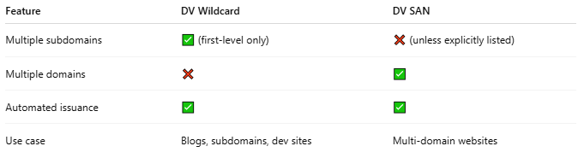
Feature | DV Wildcard | DV SAN
Multiple subdomains | ✅ (first-level only) | ❌ (unless explicitly listed)
Multiple domains | ❌ | ✅
Automated issuance | ✅ | ✅
Use case | Blogs, subdomains, dev sites | Multi-domain websites

One-line summary
# Source: AI Source: Provided by: [Data Path: Persons Table -> ID Column: 1, Name_En Column: Motasem Essam] -> From: [ChatGPT] on [1/18/2026]
A DV SAN certificate secures multiple domains with a single certificate and verifies only domain ownership, making it fast, cost-effective, and suitable for multi-domain setups.

